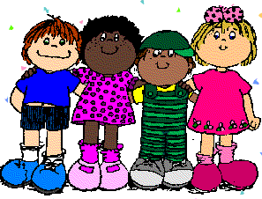

I believe birthdays are very important and should be recognized. After all, they only do come once a year. On the day of the student’s birthday, our class will be sure to congratulate the student and sing to him or her. I will then give him or her a special birthday surprise! At the end of the day, if your child would like to bring in a special treat to share, he or she may do so. I will reserve the last 20 minutes of the day to pass out the treats and enjoy them. While the students are eating, the birthday student will have the honor of sitting in the teacher's seat. The rest of the class is allowed to ask the birthday student all about him or her.

Snoqualmie Elementary school suggests that parents bring in healthy snacks for birthday celebrations. However, if your child is certain he or she would like to bring in cookies or some other sweet snack, he or she may do so. A healthy birthday snack might include Jell-O, granola bars, fruit popsicles, fruit, etc. Occasionally, food allergies may be of concern within our class. If so, I will notify all parents of these. If you have any doubt about what snack to bring, please feel free to ask!

If your child's birthday occurs during a holiday vacation and/or on the weekend, we will celebrate his or her birthday the Friday before these dates. Summer vacation birthdays will also be celebrated in our class. If your child’s birthday is in a summer month, we will celebrate his or her birthday on their half-birthday in class!

For those children who would like to celebrate their birthday outside of class as well, please refer to our class birthday directory which will be available soon. If you lose your directory during the school year, I will be happy to give you a copy, or it will also be posted on our class website. Please let me know if you have any further questions and/or concerns. I will be more than happy to assist you.

