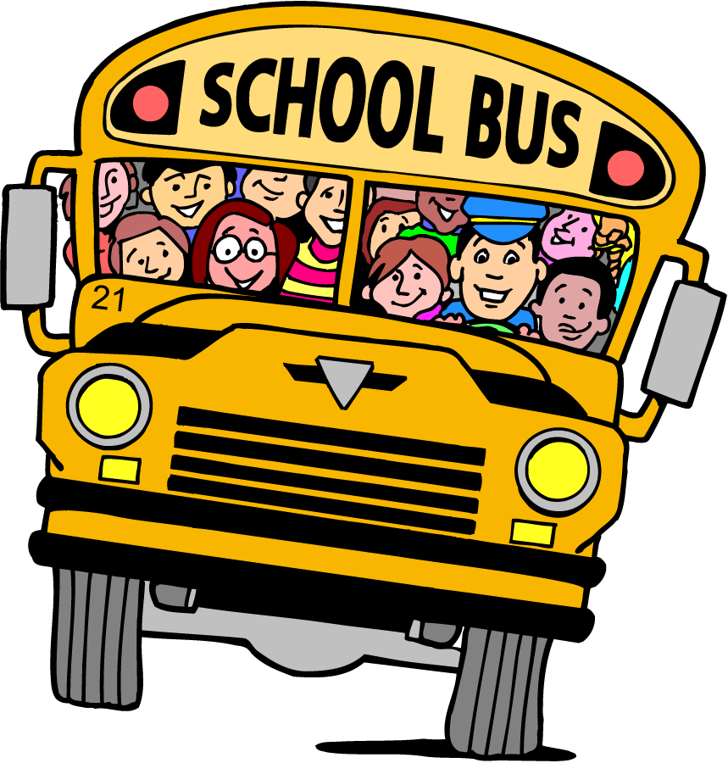

After school can be a very busy and confusing time for both students and staff! As your child's teacher, it is very important to me that we have a clear understanding of how your child will be going home each day. Therefore, to ensure correct communication between us, I will ask that you please try to follow these guidelines:

- Next to the door, I will keep an updated list of how each child is currently getting home each day of the week (parent, guardian, bus, walk, car, etc.)
- Please notify me immediately in writing or email of any changes that need to be made with regards to your child's schedule. You may also call the front office and they will let me know of the change. I prefer you email me directly if possible, as the office is very busy and dismissal time can be hectic. The night before or promptly in the morning is best. Thank you!
- If your child is going home with someone besides a parent/guardian, a written note needs to be given to the front office. I will also need an email or note as a reminder and to better assist your child.
- If your child is riding the bus with another student, the same information will need to be provided as mentioned previously. Your child will get a one day bus pass to allow them on the bus. *Please note: No bus passes are given on Fridays.
- If you are picking your child up from school, please be on time and waiting where your child can easily find you each day. It's nice to have a special meeting spot.

