Name_________________________________ Date________________

HOLIDAY ACROSTIC
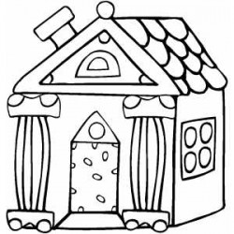
Write an acrostic poem about a holiday that your family celebrates. Begin each line with a word or phrase that starts with the letter on that line.

H________________
O_______________
L ________________
I ________________
D________________
A________________
Y________________
At home we celebrate __________________________.

