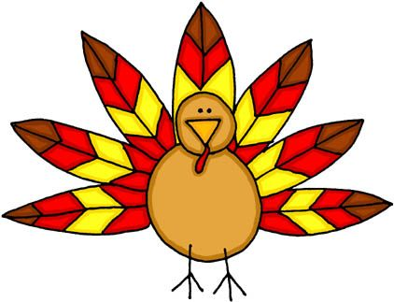
FIRST GRADE HOMEWORK PACKET
November 1-8, 2019

Families - Before Friday, Nov. 8th, be sure to give your child a spelling pre-test. Thank you!

Spelling Words from –ug Word Family: This week focuses on the spelling word
family –ug. Each word focuses on this ending sound, some with the plural ‘s’ on the end.

- bug 6. mug BONUS WORDS
- dug 7. pug 10. been
- hugs 8. rugs 11. because
- jug 9. tug 12. write
- lug

** Important Note to Parents:
Bonus Words are there for the challenge and are not counted against any child. The three bonus words are common words students will be using in their daily writing in class. Ask your child about the “because” song!

Priorities for this week are:

Reading – Read 15-20 minutes a day. Record what you read in your red folder to earn a prize. Write your daily minutes here to earn your weekly charm(s)! For every 100 minutes, you earn a charm!!!

Friday  I read  _____ minutes | Saturday  I read  _____ minutes | Sunday  I read  _____ minutes | Monday  I read  _____ minutes | Tuesday  I read  _____ minutes | Wednesday  I read  _____ minutes | Thursday  I read  _____ minutes | Total Minutes This Week  _____  minutes

Spelling – Please choose an activity from your Word Family Practice Menu. Have an adult give you a trial word family test at the end of the week.

Reading Comprehension – Please have your child read the short story or poem and answer the comprehension questions.

Math “Daily Homework” – Check your child’s take-home folder for math work completed in class. Continue to work on the reteaching, practiceor enrichment math pages in your math homework packet for our current topic.

Math Facts – Please practice the attached math pages.
- Additional online math sites are encouraged for math practice but not required.

Turkey Glyph – Parent help needed! Parents, PLEASE read directions carefully at the bottom of each page. Have fun discussing Thanksgiving together! Attached is a piece of construction paper for your child’s glyph. Remember to ONLY have your child cut and glue the turkey parts he/she colored for the glyph.

***Please return this packet on Friday, November 8th. Thank you so much for your time and support!

Student’s Name: ______________________________________________________________________

