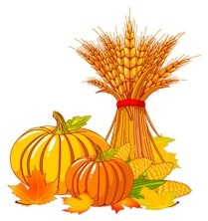
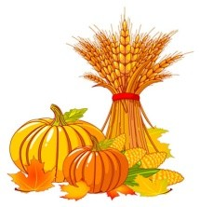
FIRST GRADE HOMEWORK PACKET
October 19 - 25, 2019

Families - Before Friday, Oct. 25th, be sure to give your child a spelling pre-test. Thank you!

Spelling Words from –op Word Family: This week focuses on the spelling word
family –op. Each word focuses on this ending sound, some with ‘s’ on the end.

- bop 6. mop BONUS WORDS
- cop 7. pops 10. funny
- crop 8. stop 11. pretty
- drops 9. top 12. said
- flop

** Important Note to Parents:
Bonus Words are there for the challenge and are not counted against any child. The three bonus words are common words students will be using in their daily writing in class. Ask your child about “said” going to jail!

Priorities for this week are:

Reading – Read 15-20 minutes a day. Record what you read in your red folder to earn a prize. Write your daily minutes here to earn your weekly reading charm(s)! For every 100 minutes, you earn a charm!!!
Friday  I read  _____ minutes | Saturday  I read  _____ minutes | Sunday  I read  _____ minutes | Monday  I read  _____ minutes | Tuesday  I read  _____ minutes | Wednesday  I read  _____ minutes | Thursday  I read  _____ minutes | Total Minutes This Week  _____  minutes

Spelling – Please choose an activity from your Word Family Practice Menu. Have an adult give you a trial word family test at the end of the week.

PUMPKIN BOOK PROJECT! – Please read the attached pages which explalin this fun fall project.
This is a GREAT activity to combine reading with creativity. Have fun with it and enjoy this project together. We have been learning about characters in a story and this will really reinforce their learning!
The directions say to use the “pumpkin project blueprint” which is not included. Basically, you will have your child pick one of their favorite stories and decorate a pumpkin to look like the main character. They will then complete two short writing pages which are found in the packet. The pumpkin, the book and the writing will be due this FRIDAY, OCTOBER 25th.
Your child’s book project is due on October 25th and they will decorate the library until the 31st. We will be using the pumpkins during our harvest party on the 31st for a fun weighing and circumference lesson and then will send them home.

*Please return this packet no later than Friday, October 25th. Thank you so much for your time and support!

Student’s Name: ______________________________________________________________________

The Pumpkin Book Project Examples
