Mrs. Heinz’s
Reading Homework

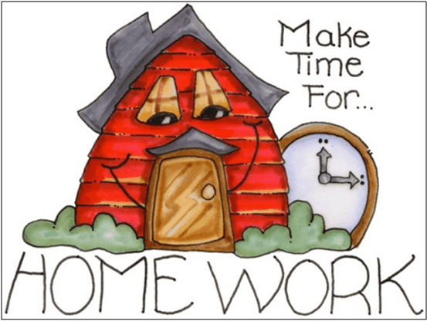

September 6, 2019
Dear Parents,
Attached is a reading log for your child to record his or her reading minutes for next week. On September 20th when we begin our weekly homework packets, your child will record his or her reading minutes on the weekly homework cover sheet throughout the rest of the year. In addition to your child’s reading log, our first homework assignment the, “Me in a Bag” activity is attached. Due to the short first week of school, these will be the only two assignments your child will receive this week. The, “Me in a Bag” assignment will be due September 11th and the weekly reading log can be turned in on Friday, September 13th. Please detach both papers before turning them in.
When completing the weekly reading logs, please note that the recommended reading time for SES first grade students is 15 or 20 minutes five days a week. The reading goal for each student in class is then 400 minutes a month. Reading at home is the most important homework activity and will be noted on each weekly homework packet. Please make reading your child’s priority each week and help ensure his or her minutes are being met. Acceptable reading minutes include you reading to your child, your child reading to you, or taking turns reading aloud with your child. As a motivation incentive, I give reading charms to all students who turn in their weekly homework packets with their minutes recorded. Students love to earn charms and receive a charm for every 100 minutes they read! Additionally, if we as a class complete our reading goal, we will celebrate with a “Hot Dog Lunch at Centennial Park,” at the end of the year. This will be explained in more detail at Curriculum Night.
Thank you for your time and support at home! If you have any questions/concerns please do not hesitate to contact me!
Sincerely,
Mrs. Heinz
catheinzses@gmail.com

