Introduction Letter

Dear Parents,

I welcome you and your children to first grade at Snoqualmie Elementary School. My name is Catherine Heinz. I am looking forward to an exciting school year!

Throughout my years in teaching, I have become committed to the importance of parent involvement in a student’s education. I believe that your child receives the best education possible when all of us work together as a team.

Within this Back To School Handbook, are the procedures and expectations of the classroom. Please read it carefully and discuss the information with your child. If you have questions and/or concerns, please do not hesitate to contact me. It is important that your child knows you understand and support these classroom expectations and standards.

I plan to keep in touch with you throughout the school year and anticipate that you will do the same. If at any time, you have something to discuss with me, please email and/or call. I will respond as soon as possible. If you are in need of immediate contact and I am not available, please contact the school office and they will be able to locate me quickly. My contact information is provided below. The school office number is 425-831-8050.

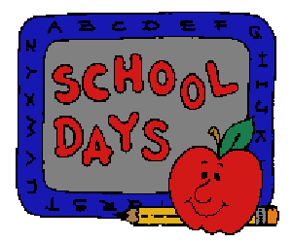
Thank you for your time and effort in making your children’s education the fullest. We will have a great time this coming school year!

Sincerely,
Catherine Heinz
catheinzses@gmail.com
425-831-8053

